**Ideation Phase**

**Define the Problem Statements**

|  |  |
| --- | --- |
| Date | 22 June 2025 |
| Team ID | LTVIP2025TMID56697 |
| Project Name | LearnHub: Your Center for Skill Enhancement |
| Maximum Marks | 2 Marks |

**User Problem Statement for Online Learning Platform (OLP)**

**Students and self-learners** often face difficulty accessing flexible, high-quality, and affordable education that fits their individual schedules and learning styles. Many existing platforms are either too complex, lack interactivity, or fail to provide clear progress tracking and certification.

They experience problems such as:

* Difficulty finding structured, skill-based courses
* Inability to learn at their own pace
* Lack of engaging and interactive learning tools
* Poor user interface and navigation
* Limited access to course-related support and guidance

Our **Online Learning Platform (OLP)** is designed to solve these challenges by:

* Providing a user-friendly, intuitive interface
* Offering self-paced, modular courses with multimedia content
* Enabling interaction through forums, chat rooms, and live webinars
* Tracking progress and offering digital certificates
* Supporting access across all devices at any time

By understanding these issues from the student’s point of view, our platform focuses on delivering a seamless, engaging, and empowering online learning experience that adapts to every user’s learning journey.

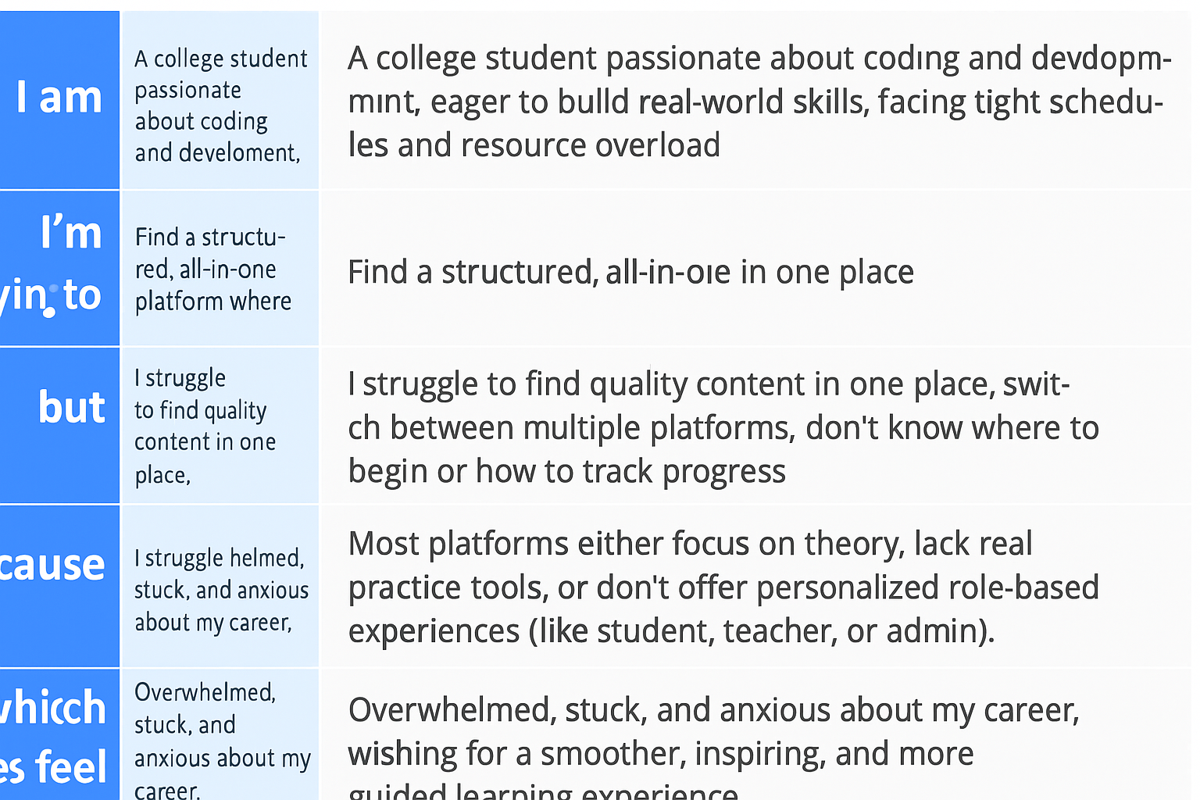

Reference: <https://miro.com/templates/customer-problem-statement/>

**Example:**

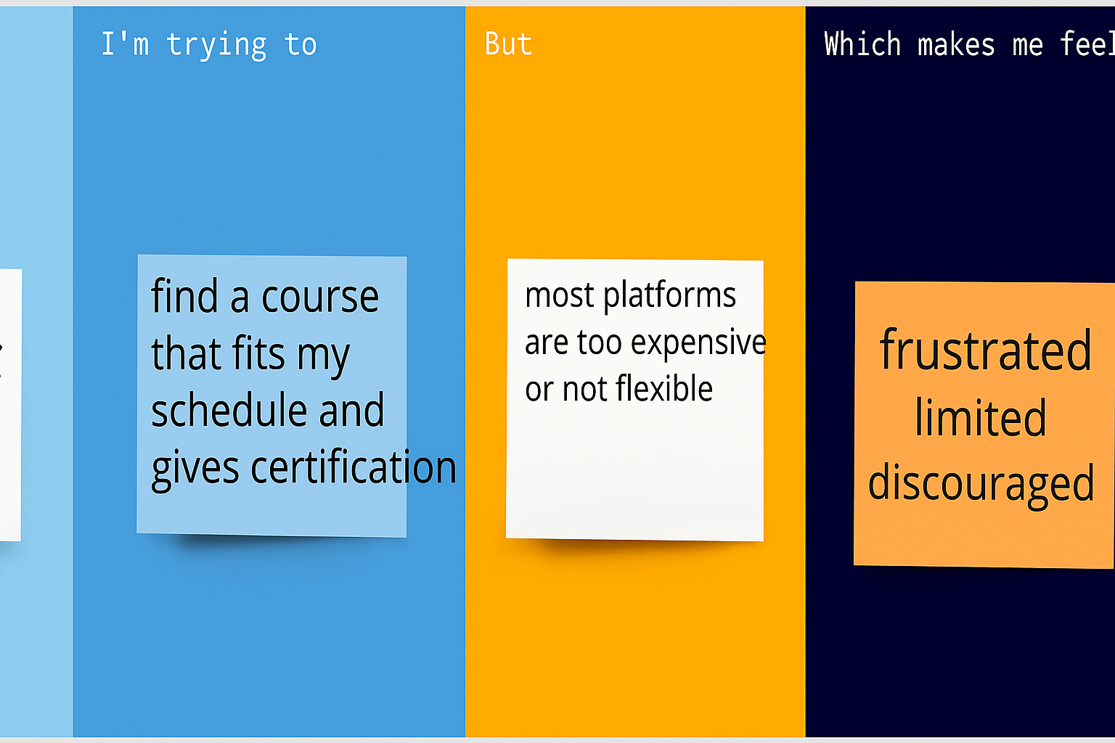

| **Problem Statement (PS)** | **I am (User/Student)** | **I’m trying to** | **But** | **Because** | **Which makes me feel** |
| --- | --- | --- | --- | --- | --- |
| **PS-1** | a student eager to learn web development online | find a course that fits my schedule and gives certification | most platforms are too expensive or not flexible | they don't support self-paced learning or lack affordable, quality content | frustrated, limited, and discouraged |
| **PS-2** | a learner wanting to improve my skills through interaction | join discussions, ask questions, and learn from peers | some platforms lack interactive features | they don’t offer live webinars or active community forums | isolated, unsupported, and less motivated |